Customer Segmentation Report

1. Introduction
This project demonstrates customer segmentation using K-Means clustering. The objective is to group customers into distinct segments based on their demographic and financial attributes, allowing businesses to better understand and target different customer groups.
2.Abstarct
Customer segmentation is a crucial strategy in marketing and business intelligence that allows organizations to group customers based on shared characteristics, behaviors, or demographics. This project focuses on applying machine learning techniques, particularly KMeans clustering and Principal Component Analysis (PCA), to segment customers using attributes such as age, income level, and education. By standardizing data, applying clustering algorithms, and evaluating performance with metrics like silhouette score, the study provides meaningful insights into customer groups. These insights can support personalized marketing strategies, improved customer satisfaction, and enhanced business decision-making.

3.Objectives
- To analyze customer demographic and behavioral data for segmentation.
- To apply clustering algorithms (KMeans) for identifying customer groups.
- To use dimensionality reduction (PCA) for effective visualization and model optimization.
- To evaluate clustering performance using silhouette score and ensure meaningful clusters.
- To provide actionable insights for customer-targeted business strategies.

4.Scope of the model
- Data Exploration: Includes descriptive statistics, missing value handling, and filtering.
- Preprocessing: Standardization of features for better clustering performance.
- Clustering: Implementation of KMeans for customer grouping.
- Evaluation: Use of silhouette score to assess clustering quality.
- Visualization: Application of PCA for reducing dimensions and plotting customer segments.
- Application: Results can be applied in retail, bank

5. Import Libraries:-
- pandas → data handling
- matplotlib & seaborn → visualization
- StandardScaler → scaling features before clustering
- KMeans → clustering algorithm
- silhouette_score → evaluating cluster quality
- PCA → dimensionality reduction (for visualization)

6. Data Preprocessing
The dataset includes numeric features such as Age, Income, Coverage Amount, and Premium Amount. Steps followed in preprocessing include:
1. Data Loading and basic exploration :-
- df = pd.read_csv("customer_segmentation_data.csv")
- df.head()
- df.tail()
- df.describe()
- df.info()
- df.columns
- df.dtypes
2. Checking for missing values using df.isnull().sum()
3. Handling categorical features (e.g., Marital Status) using value_counts()
4. Aggregates & Statistics:-
- df["Age"].mean()
- df["Income Level"].median()
- df["Education Level"].mode()
- df.groupby("Gender")["Income Level"].mean()
- df["Customer ID"].std()
- df["Coverage Amount"].var()
- df["Marital Status"].value_counts()

7. Exploratory Data Analysis (EDA)
Various visualizations were used to understand the dataset:
- Histogram of Age distribution.
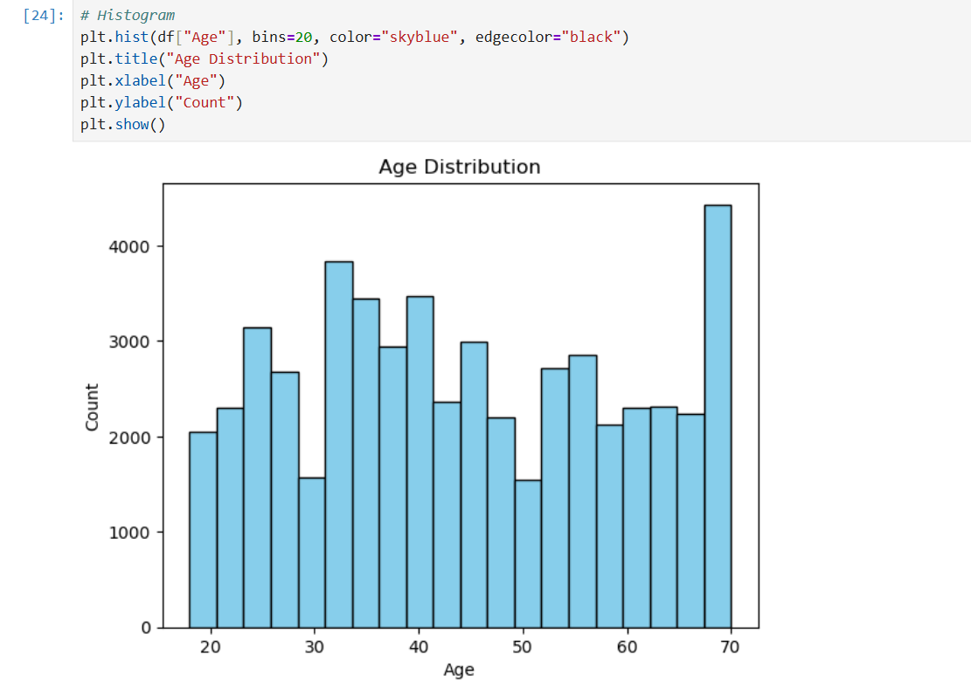

- Bar chart of marital status.
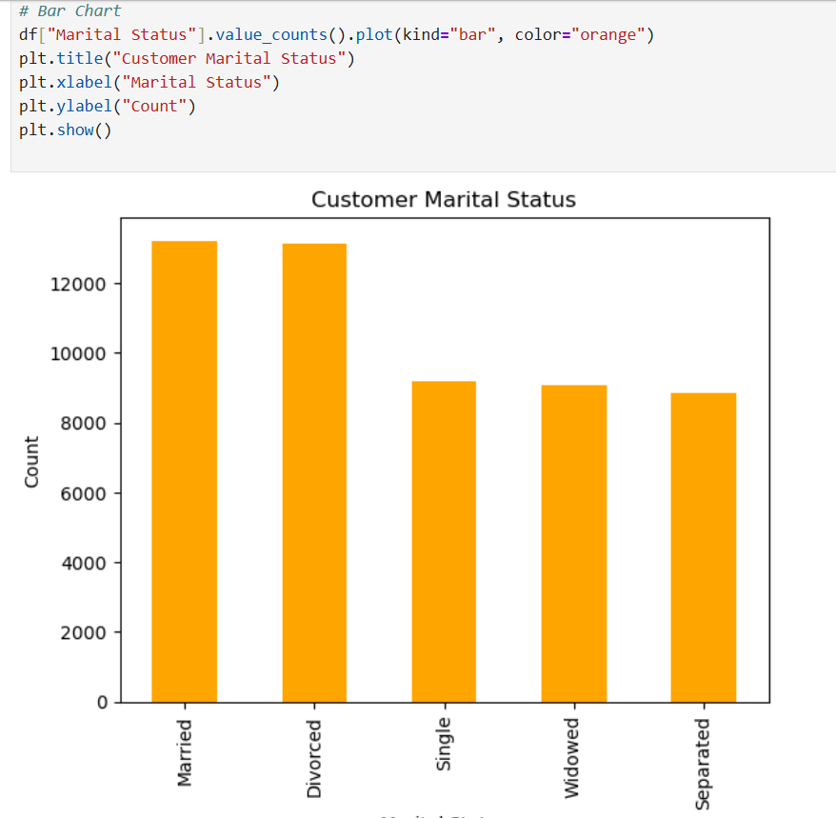

- Scatter plot of Age vs Income.
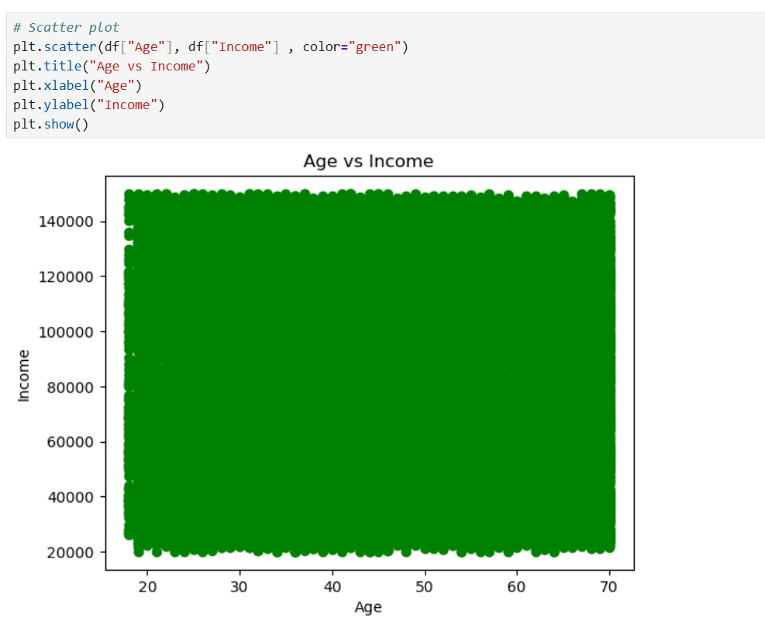

- Box plots for Income distribution.
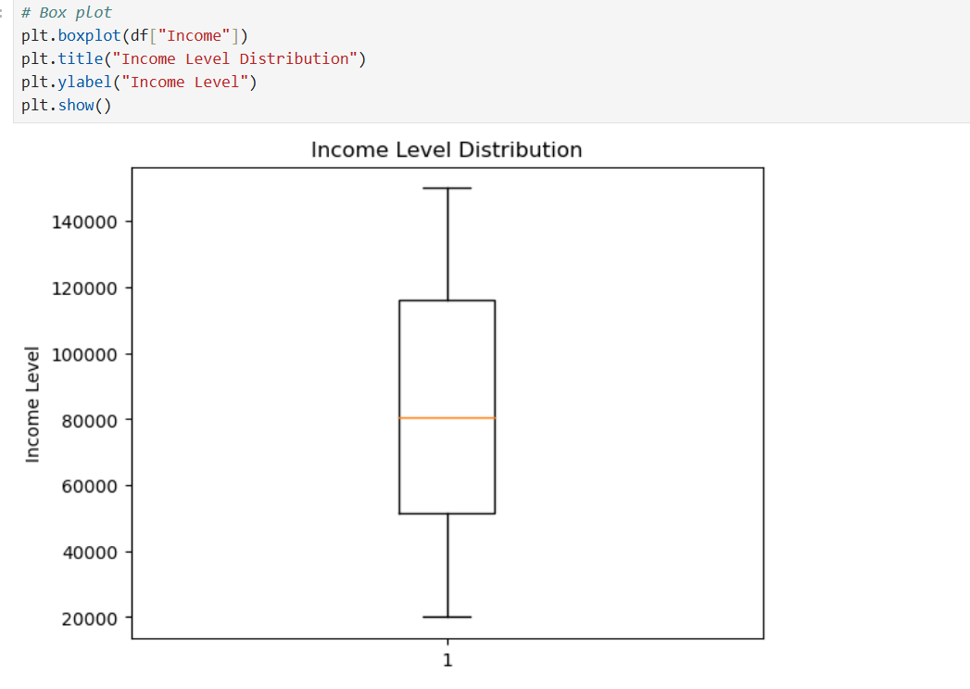

- Seaborn plots: histogram + KDE, barplot, scatterplot, pairplot.
- Pie charts for Marital Status and Policy Type.

8. K-Means Clustering
- Choose the number of clusters (k):- Decide how many groups you want to divide the data into.
- Initialize centroids:- Randomly select k points from the dataset as the initial cluster centers.
- Assign points to nearest centroid:- For each data point, calculate the distance to all centroids and assign it to the closest one.
- Update centroids:- Compute the mean of all points in each cluster and set this as the new centroid.
- Repeat steps 3–4:- Continue reassigning points and updating centroids until centroids no longer change (or change very little).
- Stop when convergence is reached:- When cluster assignments become stable (or after a set number of iterations), the algorithm ends.
- Final clusters:- The dataset is now divided into k meaningful clusters.

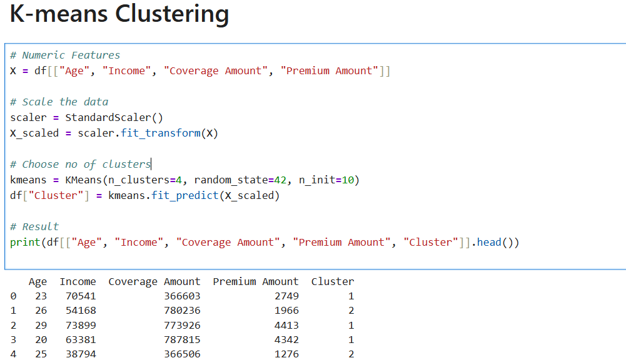

9. Elbow method:-
- Used to find the optimal number of clusters in K-Means.
- Calculate WCSS (Within-Cluster Sum of Squares) for different k values.
- Plot k vs WCSS on a graph.
- Look for the “elbow point” where WCSS decrease slows down.
- The k at the elbow is considered the best number of clusters.

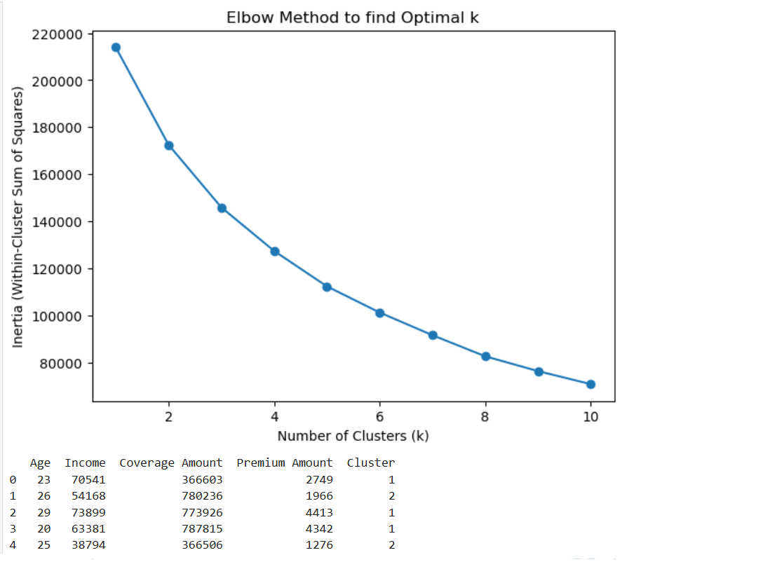

10. Silhouette Score
- Measures how well each data point fits within its cluster.
- Calculates cohesion (distance to points in the same cluster) and separation (distance to points in other clusters).
- Silhouette score ranges from -1 to 1:
  - Close to 1 → well-clustered
  - Around 0 → overlapping clusters
  - Negative → likely misclassified
- average silhouette score → better clustering.

11. PCA Visualization
Principal Component Analysis (PCA) was used to reduce the dataset dimensions to 2D for visualization. The scatter plot of PC1 vs PC2 shows customer clusters in different colors, demonstrating how well the groups are separated.
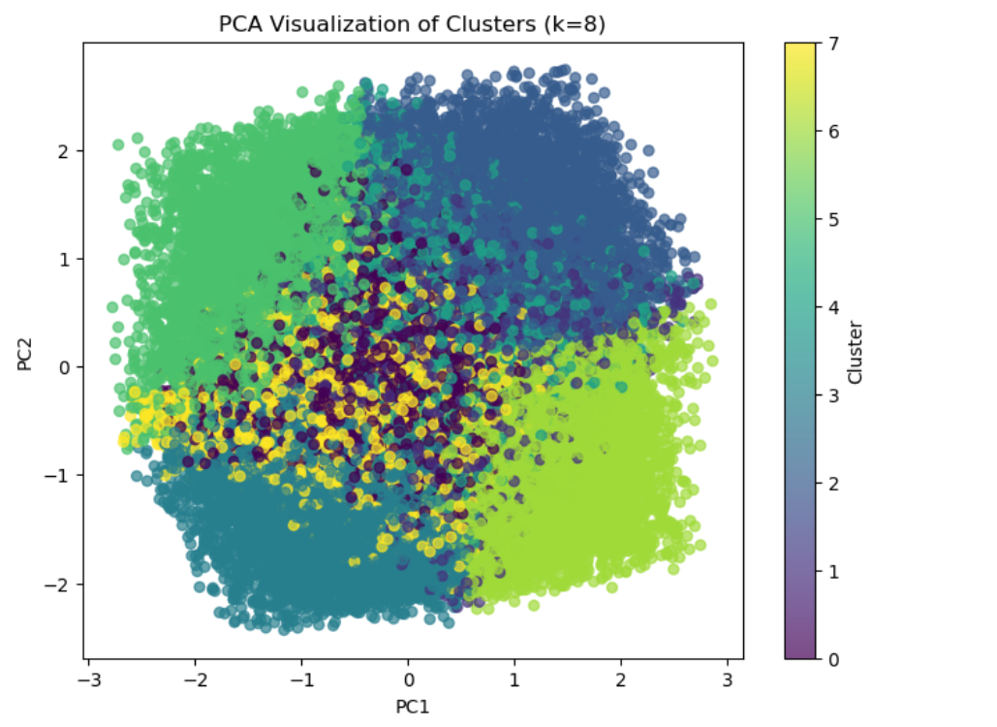

12. Conclusion
The project successfully segmented customers into optimal clusters using K-Means. The results highlight distinct customer groups based on their age, income, and policy attributes. These insights can help businesses in targeted marketing, personalized offers, and better resource allocation. Future improvements could include testing hierarchical clustering, DBSCAN, or including additional demographic features for deeper analysis.

